Office Automation Project

Contents:
1.System Requirement & Business Rules
2.Authority Management(RBAC)
3.Database Design
4.Multi-level leave request approve process

- Request Analysis & Dev Environment Preparation & Rules

Architecture Design: B/S

Brief Intro:
Each employee has his own account for this OA system. Their payments increase according to their positions ranging from P1 to P8.
P1 - P6 positions are business positions, which are in charge of the corresponding business.
P7 - P8 positions are management positions, which have the right to approve or reject the requests sent from the business positions. Specifically, P7, P8 refer to the department manager and general manager respectively.

Main Function: Leave Request Approval Process
Rules:
All employees can submit the leave request through the OA system.
If the leaving time is less than 72 hours, only the approval from P7 is required. Otherwise, the additional approval from P8 is needed.
P7 can only respond to the leave requests from his or her supervised department.
Only P8 can make a decision on the leave requests from P7.
All P8’s leave requests will be approved automatically.

Dev Environement:
java1.8
mysql 8
mybatis 3.4.6
alibaba druid 1.1.18
servlet 3.1
freemarker 2.3
layui 2.5

- RBAC role base access control
We need to bind the users with roles. Each role has different access right for resources(document, url ,. etc).

- Database Design
Basic function database design:
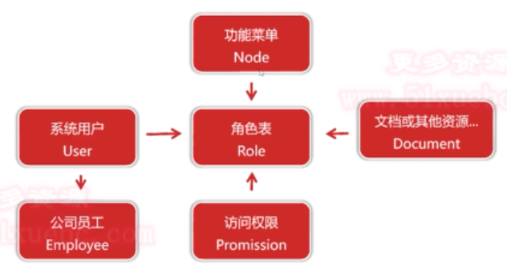
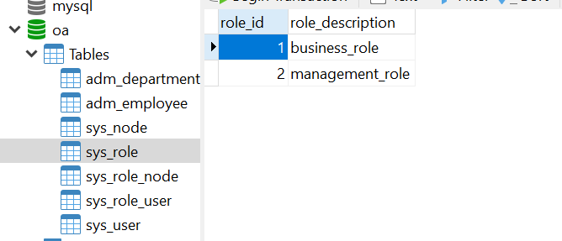
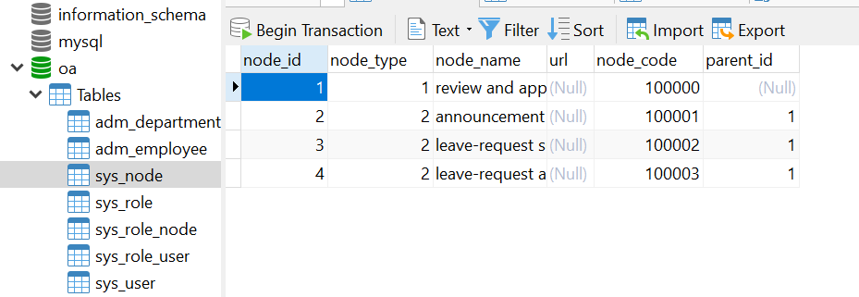
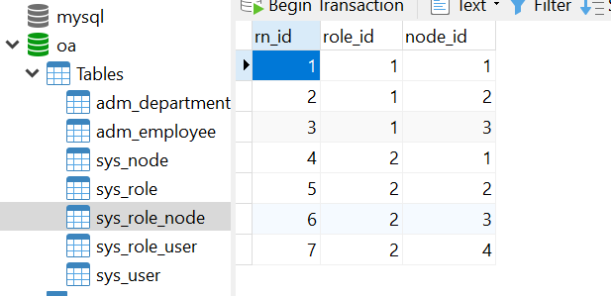
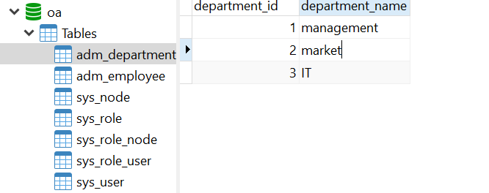
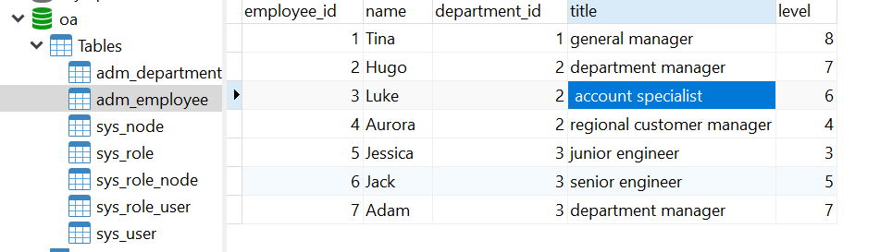
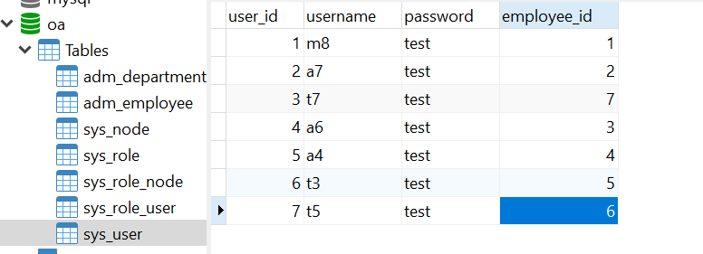
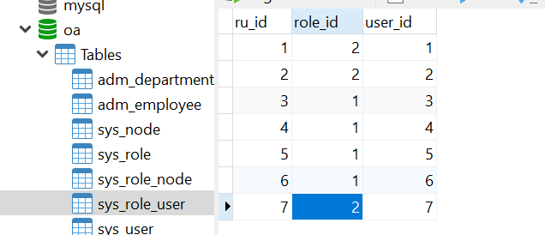

Main Function database design:

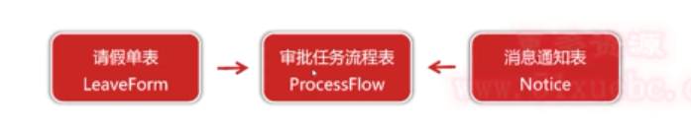
Challenge:
How to use database to represent the linear workflow ?
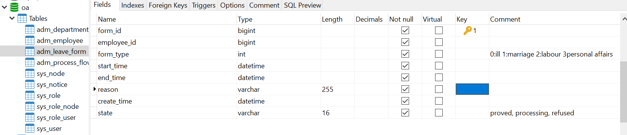
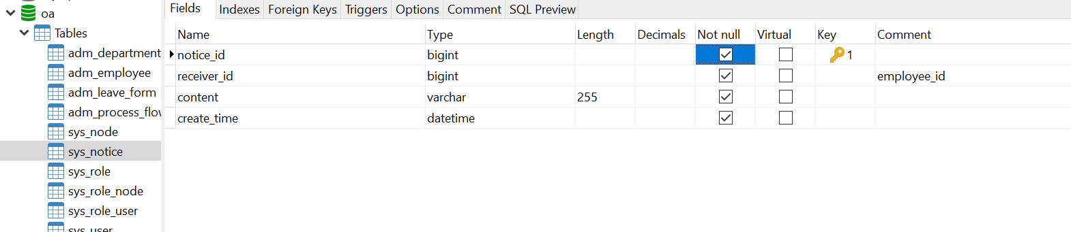

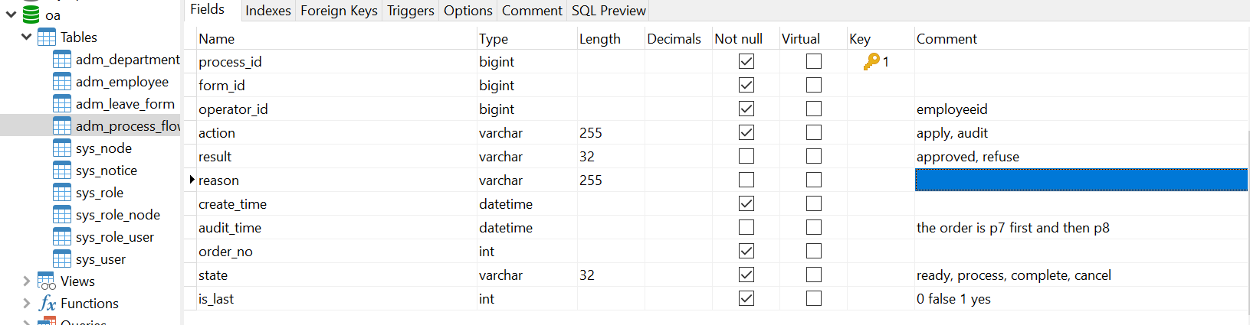

Feature
- check invalid input in login page

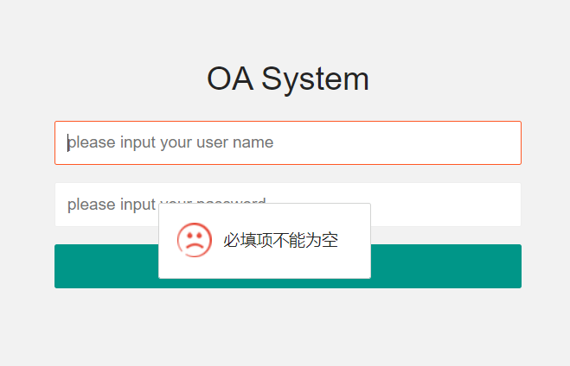
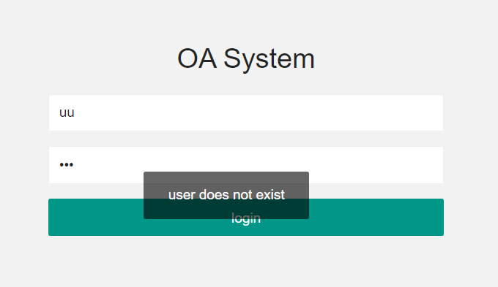

- password encryption using MD5
MD5 can generate a 128-bit hash code to identify the unique data.
MD5 is compressed with the same length.
Even a small change happens in the password, the MD5 will generate a totally different one.
It can not be cracked with the inverse engineering.
Apache commons codec package

For further safety concern,
adding salt
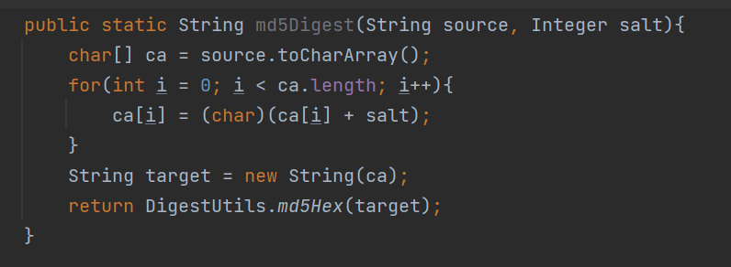

4.Multi-level leave request approve process and work representation
step 1 login user t5(IE department senior engineer-Jack) and submit a leave application.

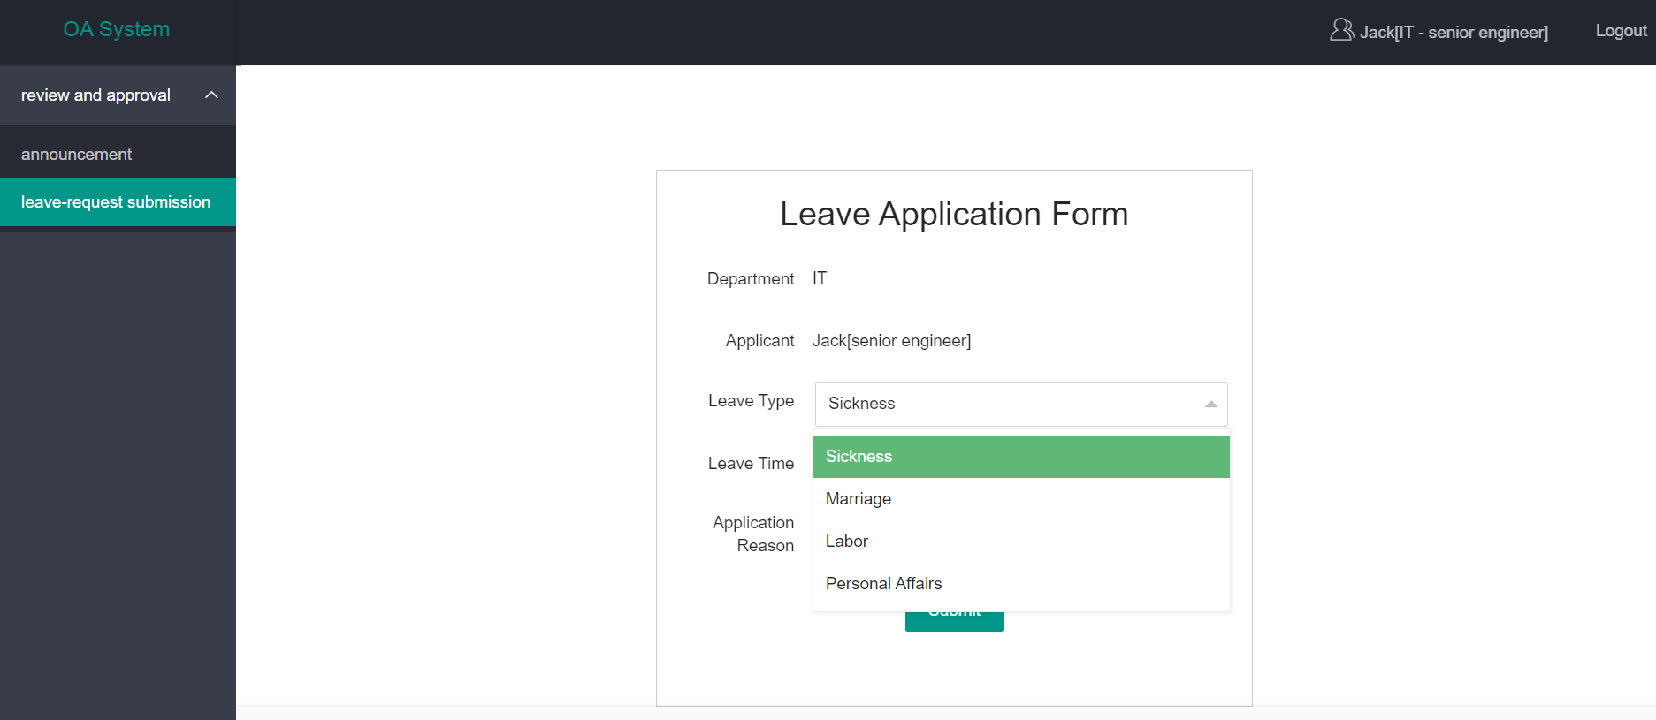
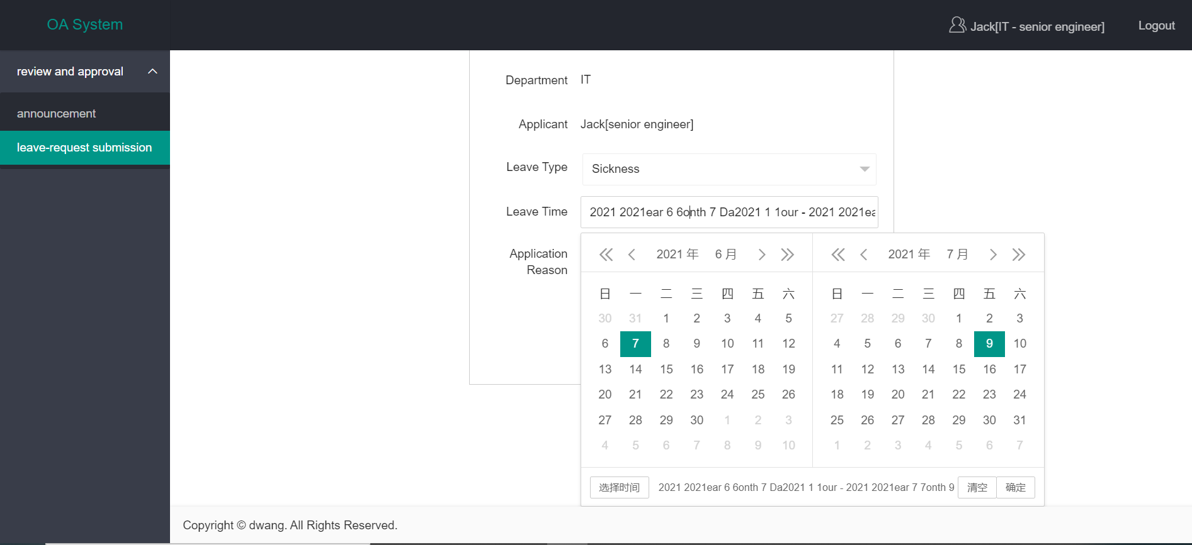
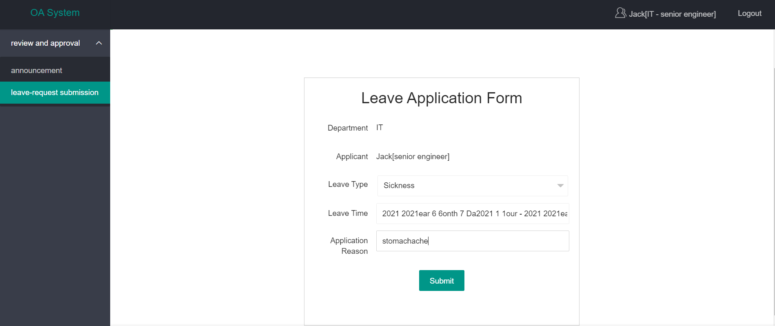

step2 login user(t7) department manager Adam to approve this application
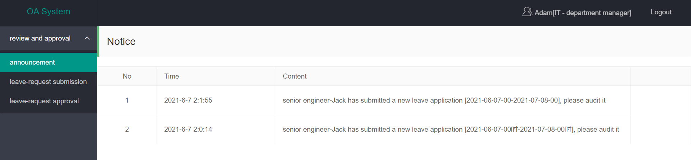

now we approve the leave application.

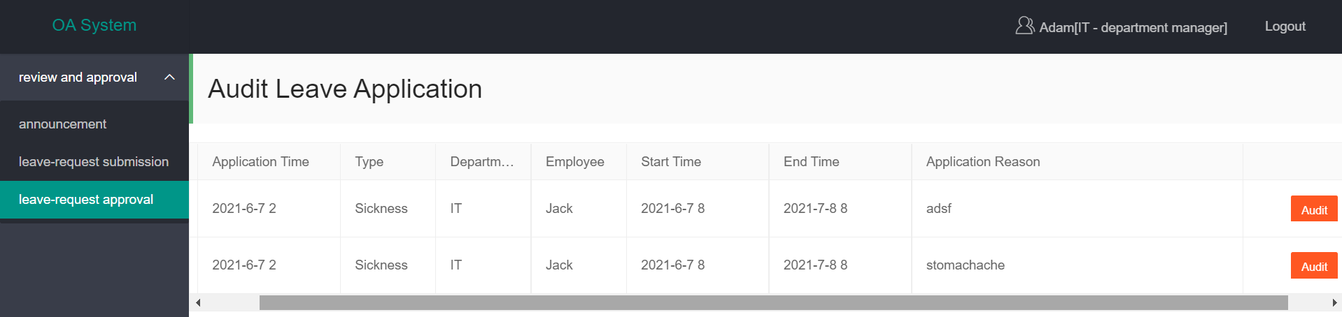

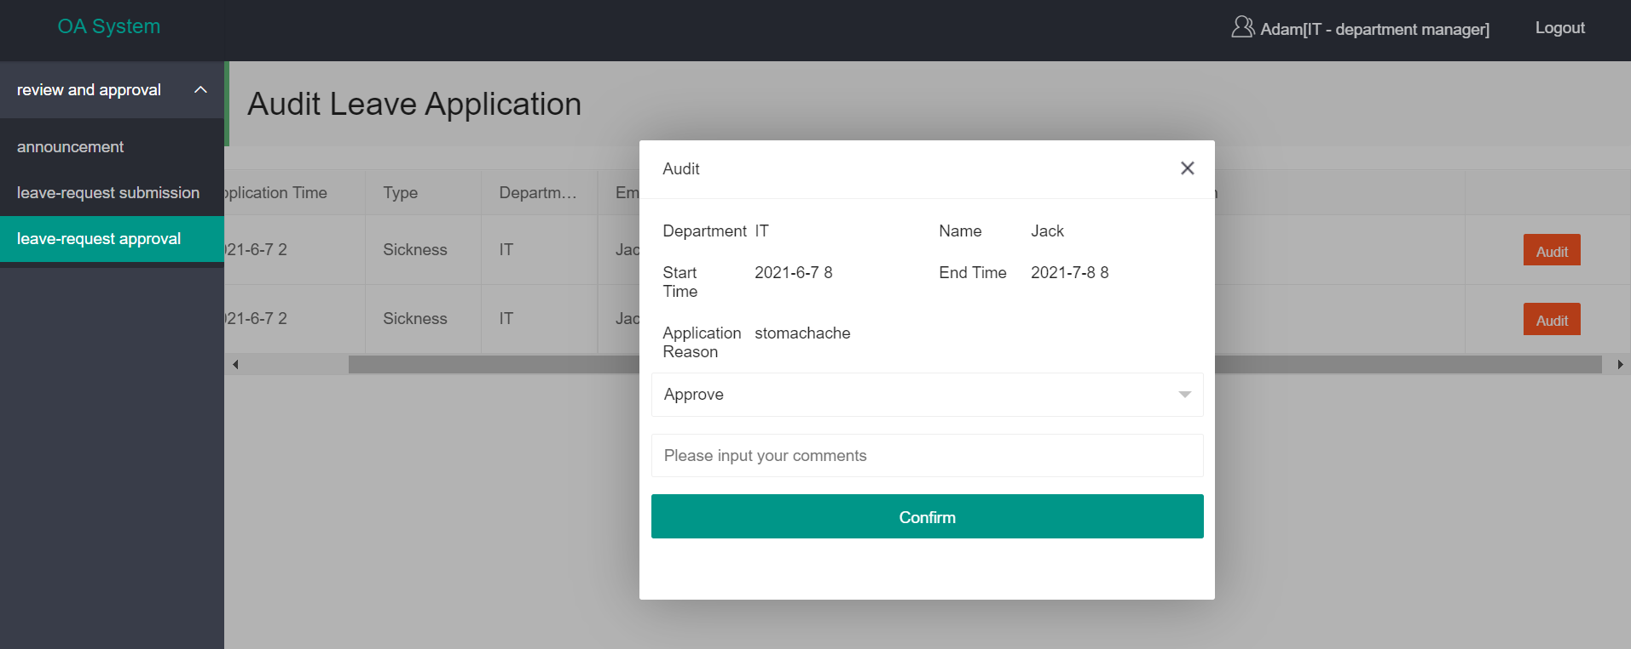
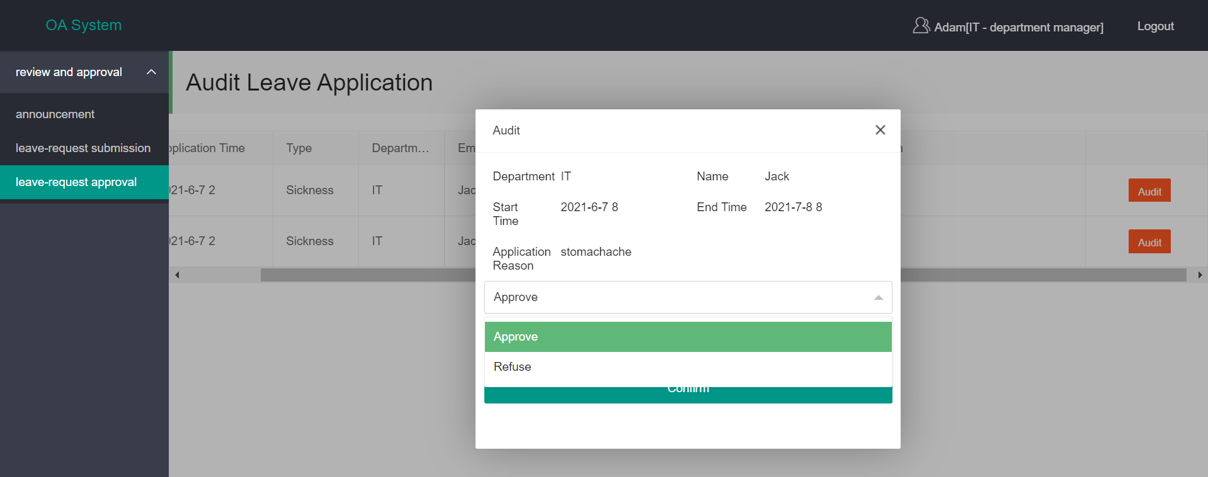
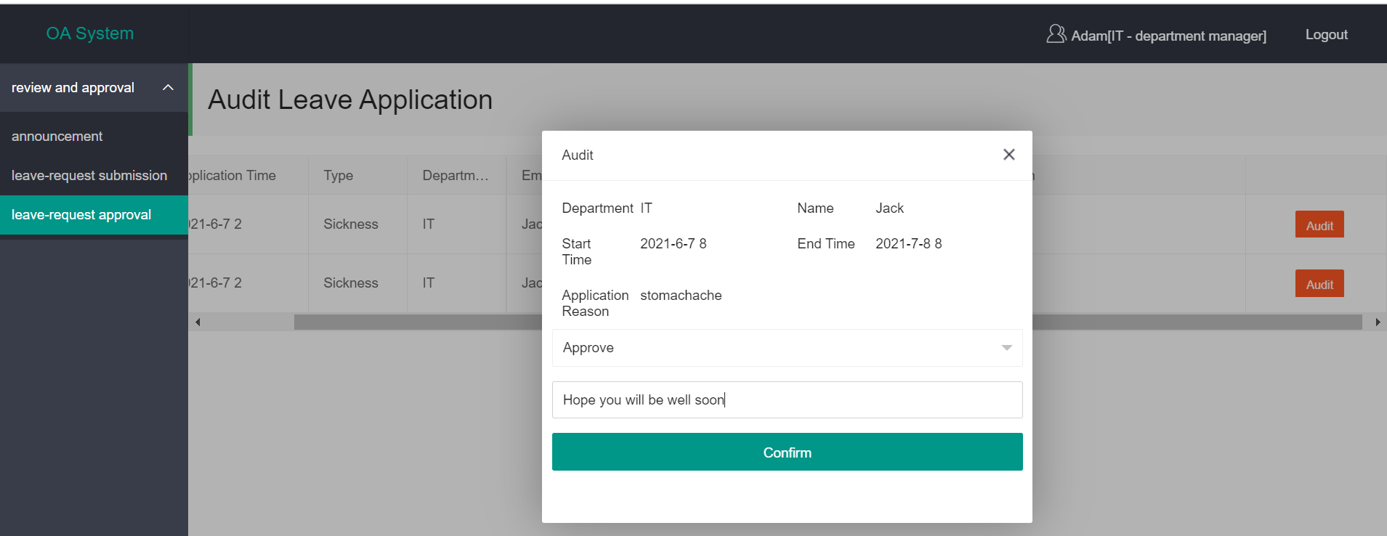

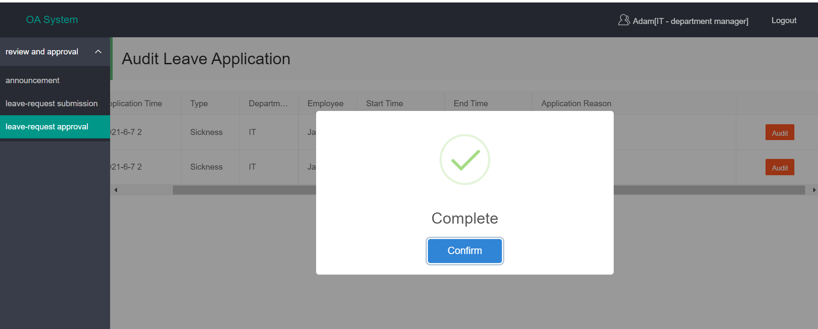

step 3, after approving this application, we will get a notice.
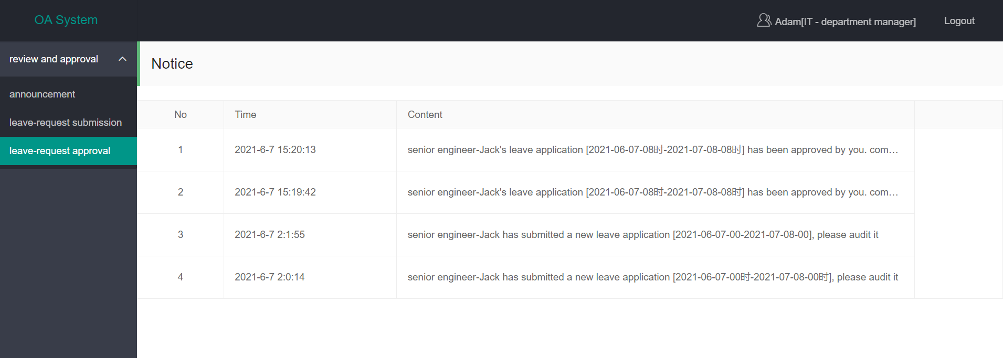

step 4, login user t5(IE department senior engineer-Jack), and Jack will get a notice, too.

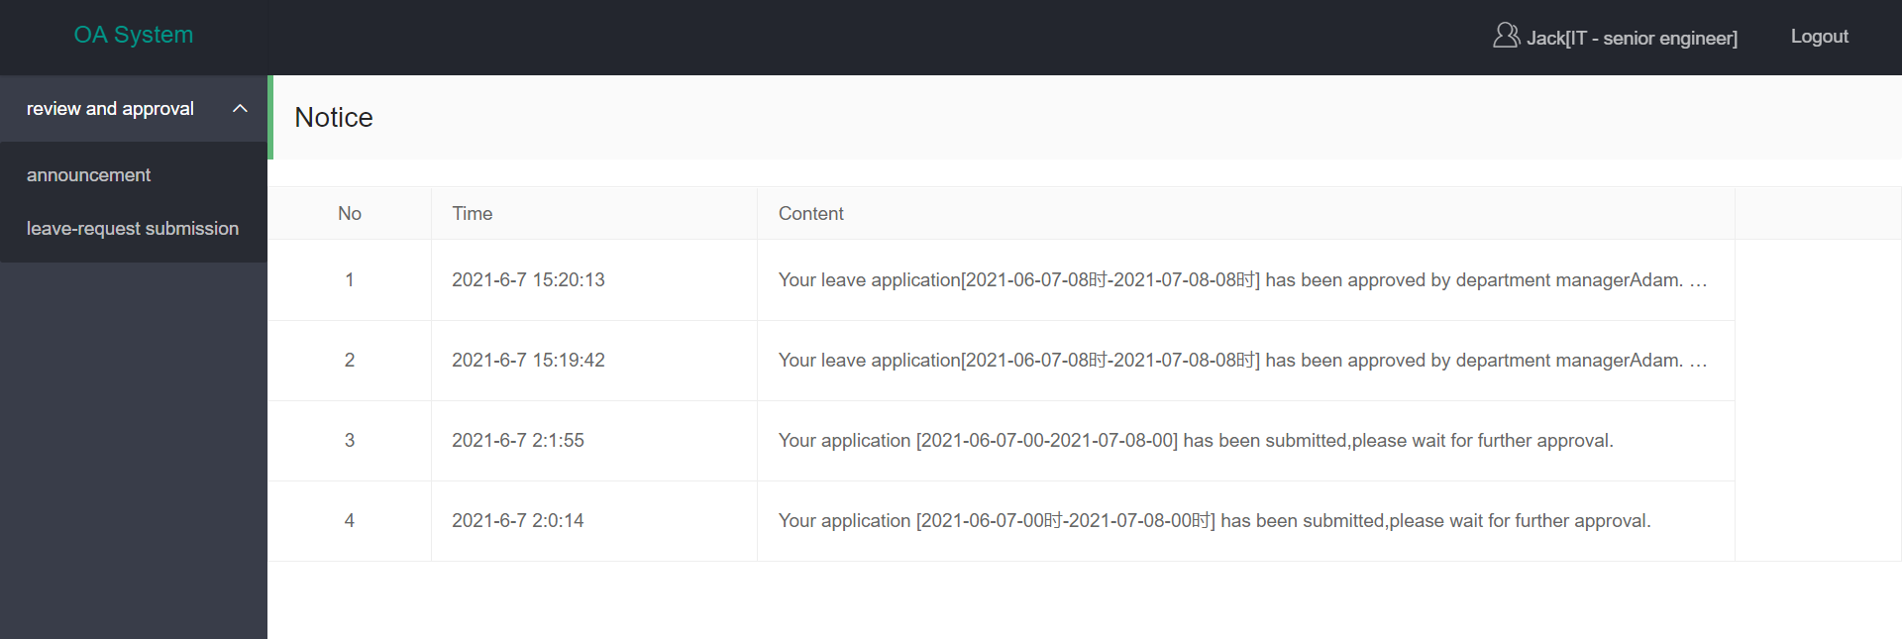

step5, login user m8 (Tina general manager), and approve the leave application.
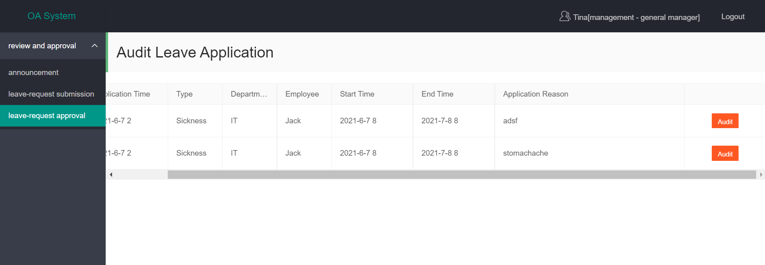

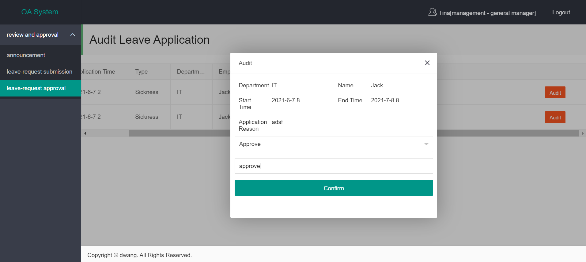
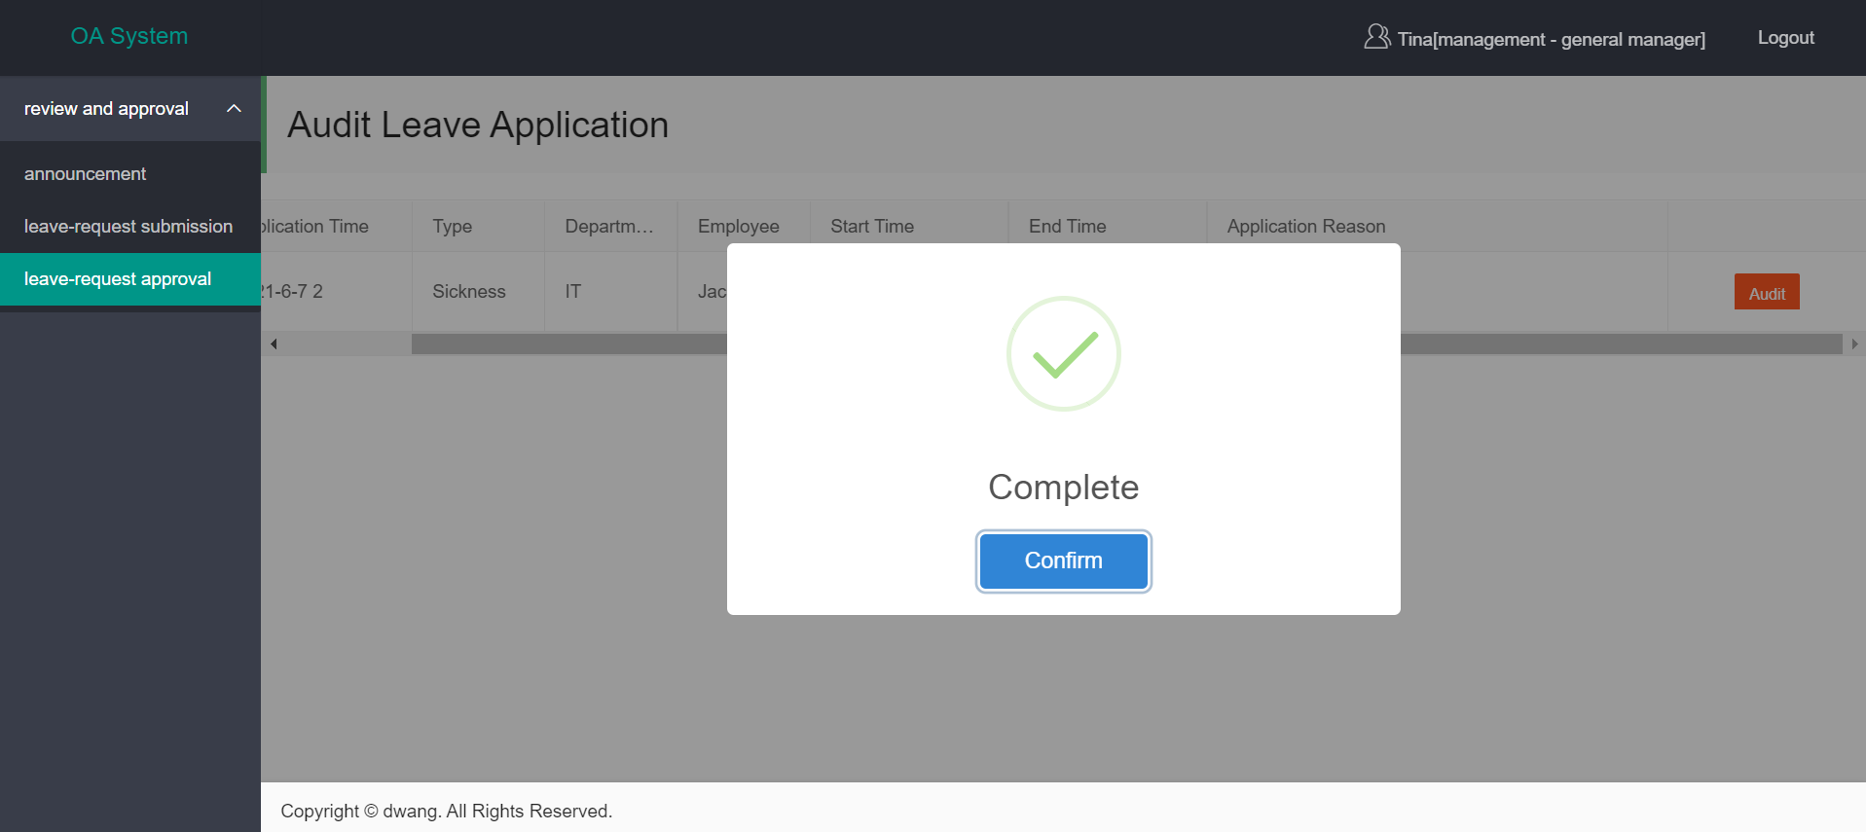

step 6, after that, both user (m8) and user (t5) will receive notices.
